SELECT with various clause – BETWEEN, IN, Aggregate function
AIM:
To view the records from the tables using SELECT commands with BETWEEN, IN, Aggregate functions.

DESCRIPTION:
➢ The BETWEEN operator allows you to specify a range to test. We often use the BETWEEN operator in the WHERE clause of the SELECT, INSERT, UPDATE, and DELETE statements.
➢ The IN operator allows you to determine if a specified value matches any one of a list or a sub query.
➢ MySQL provides many aggregate functions that include AVG, COUNT, SUM, MIN, MAX, etc. An aggregate function ignores NULL values when it performs calculation except for the COUNT function.

PART A — IN AND BETWEEN
QUESTION 1
Display customers who paid using either UPI or Cash.
This demonstrates the IN operator.
Run:
SELECT *
FROM juiceshopc
WHERE payment_mode IN ('UPI', 'Cash');
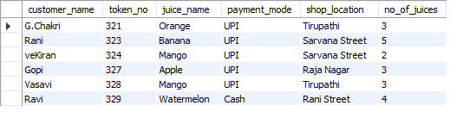
What IN means
WHERE payment_mode IN ('UPI', 'Cash')

QUESTION 2 — BETWEEN
Question
Display customers whose number of juices purchased is between 2 and 4.
Run:
SELECT *
FROM juiceshopc
WHERE no_of_juices BETWEEN 2 AND 4;
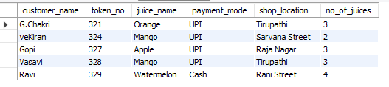

PART B — AGGREGATE FUNCTIONS
The manual specifically introduces aggregate functions such as:
AVG()
COUNT()
SUM()
MIN()
MAX()
These are used to calculate values from multiple rows.

QUESTION 3
Find the average number of juices purchased by all customers.
Run:
SELECT AVG(no_of_juices) AS average_juices
FROM juiceshopc;
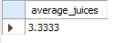
QUESTION 4 — MAX and MIN
Question
Find the maximum and minimum number of juices purchased.
Run:
SELECT
MAX(no_of_juices) AS maximum_juices,
MIN(no_of_juices) AS minimum_juices
FROM juiceshopc;

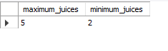
QUESTION 5 — MAX, MIN and AVG
Question
Display the maximum, minimum and average number of juices purchased.
Run:
SELECT
MAX(no_of_juices) AS maximum_juices,
MIN(no_of_juices) AS minimum_juices,
AVG(no_of_juices) AS average_juices
FROM juiceshopc;

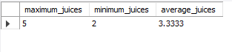
QUESTION 6 — SUM
Question
Calculate the total number of juices purchased by all customers.
Run:
SELECT SUM(no_of_juices) AS total_juices
FROM juiceshopc;
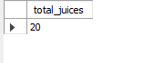
QUESTION 7 — COUNT
Question
Find the total number of customers.
Run:
SELECT COUNT(*) AS total_customers
FROM juiceshopc;
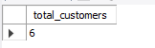

QUESTION 8 — COUNT with a condition
Question
Find how many customers purchased Mango juice.
Run:
SELECT COUNT(*) AS mango_customers
FROM juiceshopc
WHERE juice_name = 'Mango';
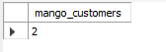
QUESTION 9 — SUM for a particular juice
Question
Find the total number of Mango juices purchased.
Run:
SELECT SUM(no_of_juices) AS total_mango_juices
FROM juiceshopc
WHERE juice_name = 'Mango';
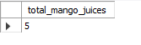

RESULT
The records were successfully displayed using the IN and BETWEEN clauses, and aggregate functions such as AVG, MAX, MIN, SUM, and COUNT were successfully performed on the juiceshopc table. This matches the objectives of Experiment 6 in the lab manual.

